***Sue Darby***  
www.sue-a-darby.com  
sue@sue-a-darby.com

January 18, 2018

**To whom it may concern**

**I am writing in regards to Brad Lentz. Brad was a colleague at Senior & Disabilities Services for the last 4 years. During this time he was a fantastic help to myself and the team. He steps up to pitch in when there was a need without complaint, He was consistently and remains constantly cheerful in the face of change and diversity of which the unit we worked in had plenty of. His positivity is contagious in a good way and if there is something new to learn he is open minded about it. He's not afraid of offering solutions to problems either.**

**Overall, Brad would make a fantastic addition to any team! I highly recommend him for any position he chooses as he is highly capable in all regards.**

**If you have further questions please feel free to reach out I'm happy to answer questions. You can reach me at 907-746-5978 or sue@sue-a-darby.com.**

Sincerely,

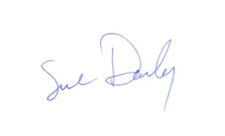

Sue Darby